**Restricting and Sorting**

**List of topics**

1. Comparison Operator(>,=,<,<=)
2. LIKE
3. Logical Operator ( BETWEEN, AND ,IN ,LIKE,AND,OR,NOT)
4. Order By

**Practice Questions**

1. Display last name and department number for employees earning more than $12000
2. Display last name and salary for all employees whose salary is not in the range of $5000 and $12000 and are in department 20 or 50
3. Display last name, JOB_ID, and start date of employees hired between Feb 20, 1998 and May 1, 1998. Order the results in ascending order of Start Date
4. Display the Last Name and Hire Date of every employee, who was hired in 1994
5. Display the last name and job title of all employees, who do not have a manager
6. Display the last name, salary and commission percentage for all employees who earn commissions. Sort data in descending order of salary and commissions
7. Display the last names of all employees where third letter of the name is an a
8. Display the last name of all employees who have an a and an e in their last name
9. Display last name, job and salary for all employees who job is sales representative or stock clerk and whose salary is not equal to $2500, $3500, or $7000
10. Display last name, salary and commission percentage for all employees whose commission percentage amount is 20%

**Character Function**

**List of topics**

1. Character – LOWER, UPPER, CONCAT, SUBSTR, LENGTH, INSTR, LPAD, RPAD, TRIM, REPLACE
2. General – NVL, CASE, DECODE
3. Number – ROUND, TRUNC, MOD
4. Conversion – TO_CHAR, TO_NUMBER, TO_DATE
5. Date – MONTHS_BETWEEN, ADD_MONTHS, NEXT_DAY, LAST_DAY, ROUND, TRUNC
6. For each employee, display employee Id, last name, Salary, and the salary increased by 15% and expressed as a whole number. Label the column as New Salary. Add one more column that subtracts the old salary from New Salary and label the column as increase
7. For each employee, display the last name and calculate the number of months worked between today and the date the employee was hired. Label the column MONTHS_WORKED. Order your results by the number of months worked. Round the number of months up to the closest whole number
8. Write a query that produces the following for each employee

employee <last name> earns <salary> monthly but wants <3 times salary>. Label the column, “Dream Salaries”

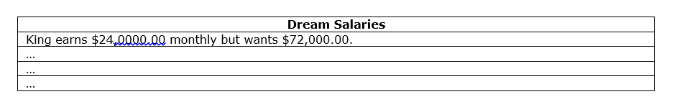

1. Display each employee’s last name, hire date, and salary review date, which is the first Monday after six months of service. Label the column, REVIEW. Format the dates to appear similar to “Monday, the Thirty-First of July, 2000”
2. Display last name, hire date, and day of week on which employee started. Label the column “DAY”. Order the results by the day of the week starting with Monday
3. Create a query that displays the employees’ last names and commission percentages. If an employee does not earn commission, put “No Commission.” Label the column COMM
4. Create a query that displays the employees’ last names and indicates the amounts of their annual salaries with asterisks. Each asterisk signifies a thousand dollars. Sort the data in descending order of salary. Label the column EMPLOYEES_AND_THEIR_SALARIES

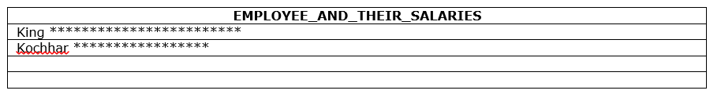

1. Using the decode function, write a query that displays the grade of all employees based on the value of the column, JOB_ID, as per below

JOB GRADE

AD_PRES A

ST_MAN B

IT_PROG C

SA_REP D

ST_CLERK E

None of the above 0

1. Rewrite the preceding SQL with case statement

**Joining Table**

**List of Topics**

1. Inner Join
2. Outer Join
3. Left Join
4. Right Join

**Practice Questions**

1. Write a query to display last name, department number, and department name for all employees
2. Create a unique listing of all jobs that are in department 80. Include Location of department 80 in the output
3. Write a query to display the employee last name, department name, Location Id, and City of all employees who earn a commission
4. Write a query to display the last name, job, department number, and department name for all employees, who work in Toronto
5. Display employee last name, employee number along with their manager’s last name and manager number
6. Display employee last names, department numbers and all employees who work in the same department as a given employee (Colleague)
7. Query to display name, job, department name, salary and salary grade for all employees
8. Query to display name and hire date of any employee, hired after employee Davies
9. Display names and hire dates for all employees, who were hired before their managers, along with the manager’s name and hire dates

**Aggregation**

List of Topics

* Group Funtion : AVG,COUNT,MAX,MIN,STDDEV,SUM,VARIANCE,GROUP BY, HAVING,NVL

1. Display highest, lowest, sum and average salary for all employees
2. Display minimum, maximum, sum and average salary for each job type
3. Write a query to display the number of people with the same job
4. Determine the number of managers without listing them. Label the column “Number of Managers”
5. Write a query to display difference between highest and lowest salaries
6. Display Manager Number and the salary of the lowest paid employee for that manager. Exclude anyone whose manager is not known. Exclude any groups, where the minimum salary is less than $6,000. Sort the output in descending order of salary
7. Query to display each department’s name, location, number of employees and average salary for all employees in that department. Round the salary to two decimal places
8. Create a query that will display the total number of employees and of that total, the number of employees hired in 1995, 1996, 1997, 1998



1. Display Job, Total salary for that job and total salary for that job against department 20, 50, 90

**Set Operators**

List Of Topics

* Union, Union All, Intersect,Minus

Practice Questions

1. List the department Ids for department that do not contain the Job Id ST_CLERK using SET operators
2. Display the Country Id and names of the countries that have no departments located in them, using SET operators
3. Produce a list of jobs for departments 10, 50 and 20, in that order. Display JOB Id and Department Id, using SET operators
4. List the employee Ids and Job Ids of those employees who are currently in the job title that they have held once before during their tenure with the company

**SET 2**

**Analytical Funcntions**

List of topics

* Row_Number,Rank,Dense_Rank,First_Value

1. For each employee, display Employee Id, Last Name and also the count of employees in the same department
2. Display LAST_NAME, DEPARTMENT_ID, SALARY and Previous Highest salary within that department. Order the results by Department Id and in descending order of salary
3. Display Employee’s Last Name, Salary and their rank in accordance to descending order of their salary. Ensure that no ranks are skipped
4. For all employees, display the DEPARTMENT_ID, LAST_NAME, SALARY along with LAST_NAME of the employee who earns lowest salary in that department

**Subqueries**

List of topics

* In,Having,Exists,With

1. Write a query to display last name, hire date of any employee in the same department as Zlotkey. Exclude Zlotkey
2. Display Employee Numbers and last names of all employees who earn more than the average salary
3. Query to display employee numbers and last names of all employees who work in a department with any employee whose last name contains a u
4. Display last name, department number, and job id of all employees whose department location Id is 1700
5. Display last name and salary of every employee who reports to King
6. Display employee numbers, last names and salaries of all employees who earn more than the average salary and who work with any employee with a u in their name
7. Write a query to display last name, department number and salary of any employee whose department number and salary both match the department number and salary of any employee who earns a commission
8. Display last name, department name and salary of any employee whose salary and commission match the salary and commission of any employee located in Location Id 1700
9. Query to display last name, hire date and salary for all employees who have same salary and commission as Kochhar